Table of Contents
1.0 Introduction 3
1.1 Variables Used 3
2.0 Gathering Raw Data & Basic Cleaning 4
2.1 Downloading Games 4
2.2 Merging Data into a Single File 4
2.3 Splitting/Sorting the Games into Individual Files 5
3.0 Individual Move Analysis 6
3.1 Stockfish Download 6
3.2 Stockfish Analysis 6
3.2.1 Algorithm V1 6
3.2.2 Algorithm V2 7
3.2.3 Algorithm V3 9
3.2.4 Algorithm V4 12
1st Variable – Average PR per Game 14
2nd Variable – Games Played per Session 15
3rd Variable – ELO Loss/Gain per Session 16
4th Variable – Streak Record 17
4.0 Problems in the Dataset 18
4.1 Unrated Games 18
4.2 Duplicated Games 18
5.0 Compilation of the Final Dataset 19
6.0 Dataset Preprocessing 20
7.0 Model Training #1 24
7.1 Model Accuracy Score 24
7.2 Feature Importances 25
7.2.1 Dropping streak in the Dataset 26
7.2.2 Dropping Everything but streak 27
8.0 Model Training #2 28
8.1 Feature Importances 28

1.0 Introduction
This project aims to create a predictive model to predict blunders made by bullet chess players. It considers different positive and negative variables to find out how likely a blunder will be made in the following moves. The assumption of this model is that the quality of bullet chess games is less dependent on calculation but more to intuition, which is highly affected by personal emotions. Therefore, it uses different variables that might play a role in affecting a player’s emotions and finds out how much each one contributes to the quality of moves.

1.1 Variables Used
Variable | Description
Game ID | Unique Identifier for every game in the dataset
Punishment Rating | A variable derived from centipawn loss of the user’s move and evaluation after the opponent moves.  High PR = Making a bad move and getting punished.  Low PR = Making good/bad moves and getting away.
Games Played per Session | Clusters up chess games that are played simultaneously and calculates how many games have already been played in that session.
ELO Loss/Gain per Session | Figures out ELO at the start of the session and subtracts it from the current ELO. A positive result indicates gaining ELO while a negative one indicates losing ELO.
Streak Record | Counts the number of wins/losses in a row and records it, with a positive number indicating wins and a negative number indicating losses. Draws are always counted as 1.

2.0 Gathering Raw Data & Basic Cleaning

2.1 Downloading Games
The method that will be used to gather raw data for analysis is by downloading all chess games ever since 1700 ELO was achieved in September 2022. A bot was crafted to download chess games from 7th July 2025 (today) till December 2022. This takes the game archives back 180 pages, with 50 games per page. Therefore, a grand total of 9,000 games was downloaded in the Portable Game Notation (.PGN) format which can be read using a text editor. Each record notes down the date, time, ELO rating, result, and moves as its included metadata.

2.2 Merging Data into a Single File
Before any further actions, all 9,000 games are merged into a single file called Compiled_Games.txt. From here, they will then be cleaned and sorted. Each game will then be assigned a unique Game ID that increases through time. Unnecessary headers from the PGN file will also be deleted as shown below.

[Event "Live Chess"] ❌ Deleted
[Site "Chess.com"] ❌ Deleted
[Date "2022.12.26"] ✅ Used for session clustering
[Round "-"] ❌ Deleted
[White "Random"] ❌ Deleted
[Black "IgniteZeus"] ✅ Used to find out starting colour
[Result "1-0"] ✅ Used to determine result
[WhiteElo "1715"] ✅ Used to determine ELO difference/loss
[BlackElo "1712"] ✅ Used to determine ELO difference/loss
[TimeControl "60"] ❌ Deleted
[EndTime "15:05:42 GMT+0000"] ✅ Used for session clustering
[Termination "Random won on time"] ❌ Deleted
Moves ✅ Used to evaluate performance

2.3 Splitting/Sorting the Games into Individual Files
Next, another script was crafted to remove the headers as shown above and to split all the games into their own files named with their individual IDs. The IDs are sorted based on the game’s age, with “ID0001” being the oldest game in the database.
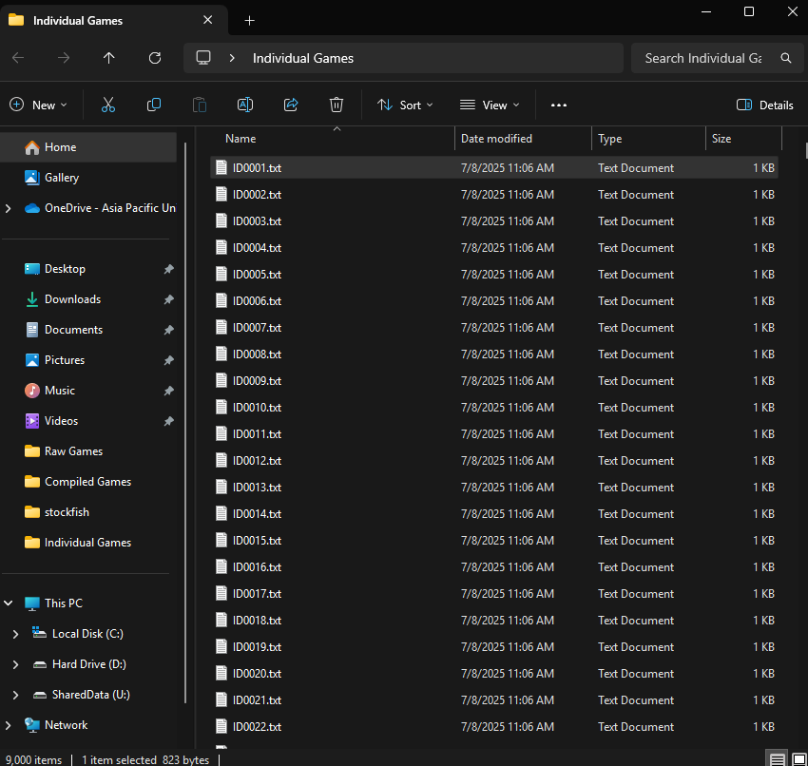

3.0 Individual Move Analysis

3.1 Stockfish Download
To analyze individual moves for the derived variables like centipawn loss or move accuracy and extreme blunders, Stockfish was chosen as it provides the most accurate calculations. Another chess engine called Leela Chess Zero was also considered as it utilizes GPU acceleration, but lc0 is built on Neural Networks, and will only provide win predictions, which aren’t the precise variables required.

3.2 Stockfish Analysis

3.2.1 Algorithm V1
After this, another script was crafted to find out which side the target player is on, then using stockfish to calculate their centipawn loss by subtracting the best move evaluation with the move that was made. The engine uses Depth=15 along with 10 threads and all the calculations are written in a CSV file. Assuming around 16 seconds per 40 moves and an average of 40 moves per game, the entire calculation phase is projected to take around 40 hours. A screenshot of the script running is shown below.
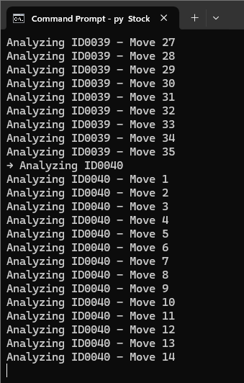

3.2.2 Algorithm V2
Due to the extreme waiting period of 40 hours, the system’s double booted Ubuntu was put to use. The previous script was modified to run in Ubuntu, but this time utilizing every thread available (16 threads in an i5-14400F) as soon as it is freed. This took the analyzing time all the way down to a little over two hours. The process is as shown below.
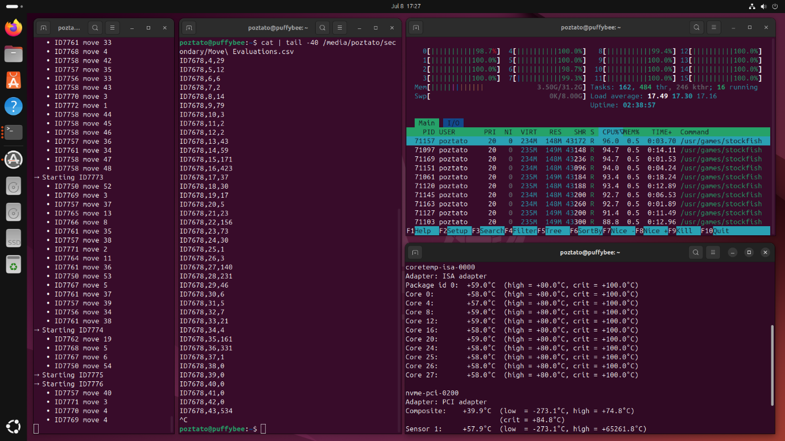
The first window shows the move and game being analyzed, the second window shows the last 40 lines of MoveEvaluation.csv, the third shows CPU utilization, and the fourth shows CPU core temperatures.
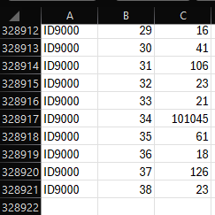
The image above shows the last few lines of MoveEvaluation.csv. The first column indicates the Game ID, the second shows the current move, and the last represents the centipawn loss of that move. As shown, the entire file contains 328,921 rows ready for transformation.
This, however, introduces a flaw in the variable gathering process. Using this dataset, the only information that can be obtained is how good of a move the target player made. At the time, this seemed fine as making bad moves will naturally negatively impact one’s emotions. However, this is neglecting an important aspect of bullet chess – players often don’t realize they made a bad move unless they get punished.
Another flaw of the algorithm is its way of handling checkmate evaluations. Initially, mate scores were set to 100,000 to simulate the player being completely winning. However, this logic categorizes moves that bring M5 to M8 an extreme blunder. Typically, in bullet, even losing the checkmate sequence but maintaining a strong lead like M5 to +8.0 doesn’t contribute much to emotional distress. Due to this realization, a new algorithm was made to run overnight on the 8th of July.

3.2.3 Algorithm V3
The new algorithm now runs Stockfish on moves made by both white and black in Depth=16 and takes note of the evaluations in MoveEvaluations.csv. Then, it performs a mathematical equation to find out if the target player made a mistake and how much they got punished for it. It then outputs this value as a new variable called Punishment Rating (PR), with a high value indicating that the target player got punished for their blunder, and a low rating indicating that the blunder wasn’t punished and can be ignored. Additionally, it also introduces a centipawn loss cap to checkmates, so that M5 to M8 is categorized as still the best move. On the other hand, moves like M5 to +8.0 will be punished minimally, as they should be.

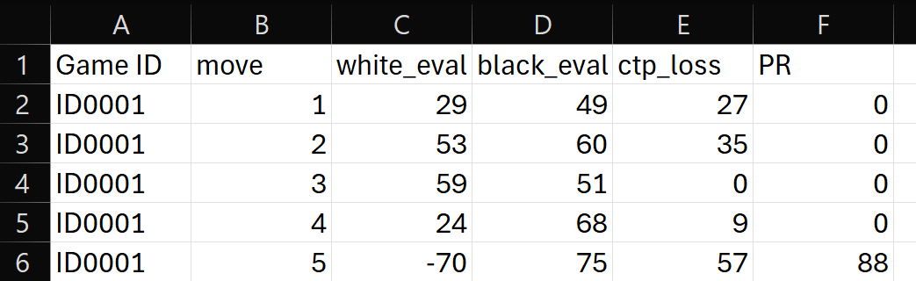
The table above shows the variables present in the new dataset, with white_eval being the evaluation at the start of the game/after black moves, and black_eval being the evaluation after white moves. Other than that, ctp_loss refers to centipawn loss of the target player’s move, and PR refers to punishment rating, the variable discussed earlier. This dataset took 5 hours to compute using the same system as before (Ubuntu + i5-14400F with 16 threads).

Exploratory Data Analysis (Algorithm V3)
After the moves have been successfully evaluated, several extreme values still exists in the Punishment Rating column. This might be due to Depth=16 being too shallow in the endgame. To identify these values, a script was crafted to extract PR values ranging from 1,200 to 10,000 and plot it against its frequency.
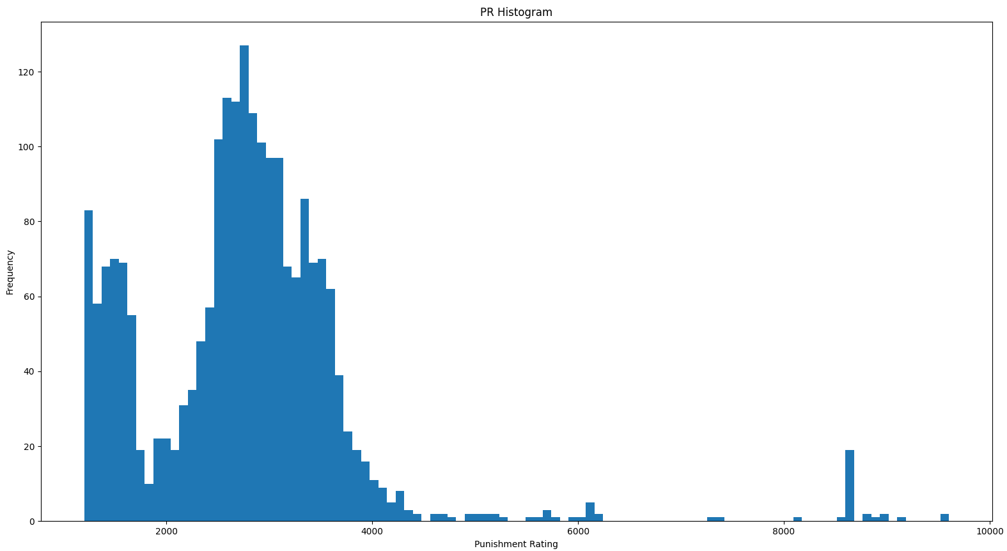
As shown, several spikes of extreme values are present within the dataset. Upon further inspection in the 5,000 to 10,000 region, it was found that these extreme values are the result of not making the most optimal move in the endgame (e.g. M6 to +79.0). As mentioned, this might be the result of using a seemingly low depth in terms of the endgame.

The scatterplot below represents Punishment Rating to Move Number and is used to identify if these values are occurring in the endgame.
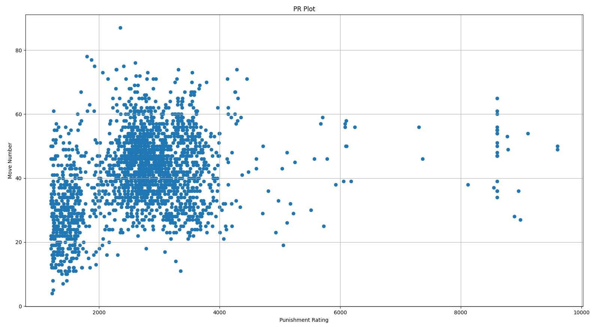
As shown, the majority of PRs above 2000 occur around move 40, signifying that it takes place in the endgame. Curiously, there is a visible lack of plots around the 1850 PR column before PRs start to populate the sub-20 moves area.
After around 10 hours of analysing, this dataset has been deemed unusable due to having completely botched PR values. Most of these values are the result of a combination between the capped checkmate score at 1000 and the engine not seeing checkmate in depth=16 and giving a high evaluation (>1000) for the position. As PR is calculated by evaluating the target player’s move compared to the next opponent’s move, a scenario where the engine only sees mate during the opponent's move would result in something like PR(8000ʰⁱᵍʰ ᵉᵛᵃˡ – 1000ᵐᵃᵗᵉ ᶜᵃᵖ), returning the value 7000.
Because of this, yet another algorithm was created but this time capping individual move evaluations to 1000, the same cap applied to checkmate scores.

3.2.4 Algorithm V4
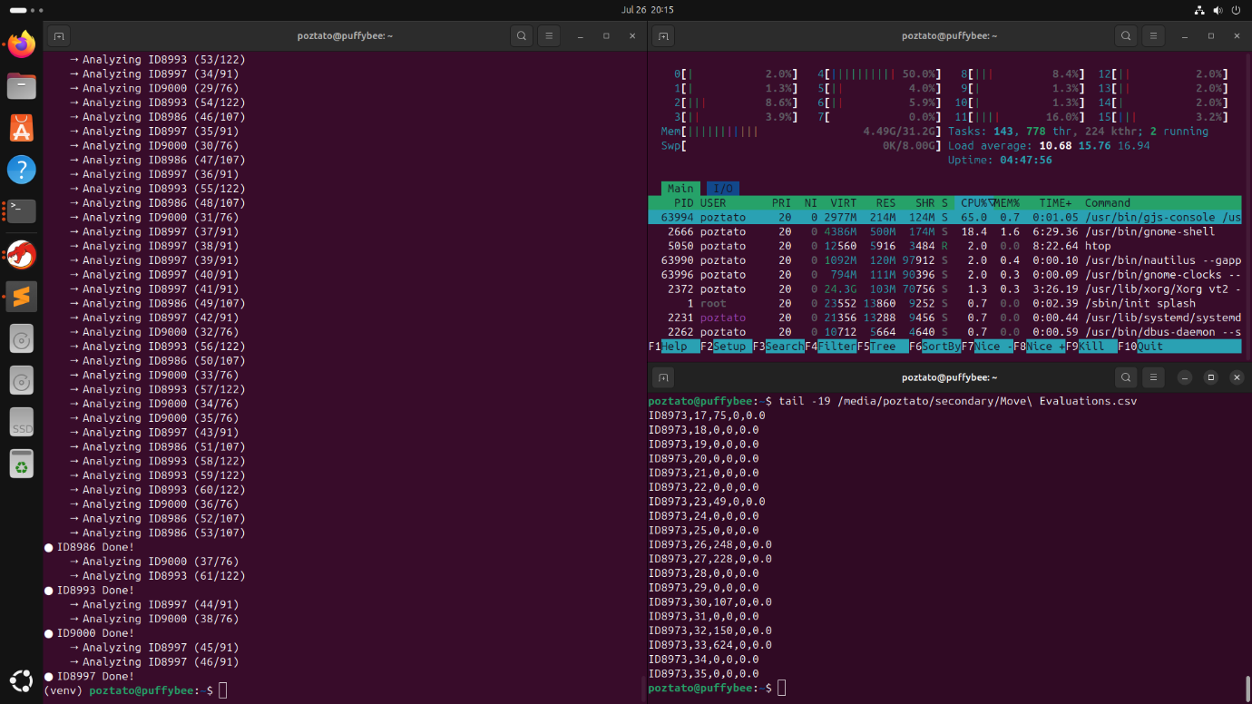
The diagram above shows the completion of Algorithm V4 for MoveEvaluations.csv. This algorithm now only evaluates what’s needed for PR calculation and drops the evaluation of eval_white and eval_black from V3. This took the run time down to approximately 4 hours and 15 minutes. Other than that, it also caps the maximum evaluation score to 1000 as mentioned before. As a result, the PR values produce are confined within 0 to 2000, finally increasing the accuracy of it representing move punishments.

Exploratory Data Analysis (Algorithm V4)
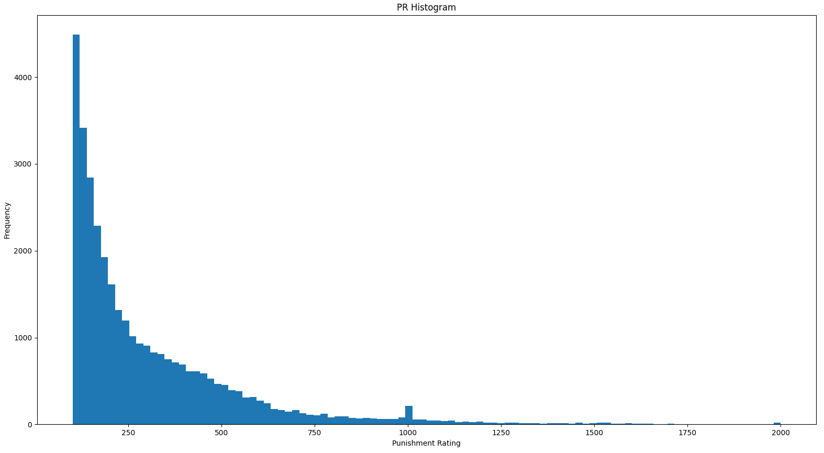
As shown, the histogram of Punishment Rating against Frequency now accurately represents what’s expected of 9000 chess games, with the frequency of higher PRs decreasing exponentially. Notably, there is a spike in PR frequency in the 1000 and 2000 range. This can be easily explained as the value 1000 represents the target player blundering checkmate from a neutral position and 2000 represents blundering checkmate from a completely winning position. These scenarios are due to the fact that both checkmate and high evaluation scores are capped at 1000.

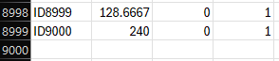
For the sake of documenting, it was found that 2 games where somehow missing from the final dataset (Index 8999 minus 1 for the header). Using a script, the two games were identified to be ID1436 and ID4567. After investigating, both games were found to have contained no moves, with ID1436 resulting in a draw and ID4567 resulting in a win. Due to this, it was decided that both games can and should be ignored in the training data.

1st Variable – Average PR per Game
After the individual move analysis has been completed, the first variable can now be derived. Using a Python script, a program will gather PR values greater than 100 and group them by game. Then, it will find the average PR value and write it to AveragePR.csv.
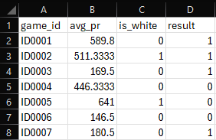
As shown, game_id refers to the unique identifier of each game, avg_pr refers to the calculated average PR value, is_white returns 1 if the target player is white and 0 for a black, and result returns 1 for a win, 0 for a loss, and 0.5 for a draw.

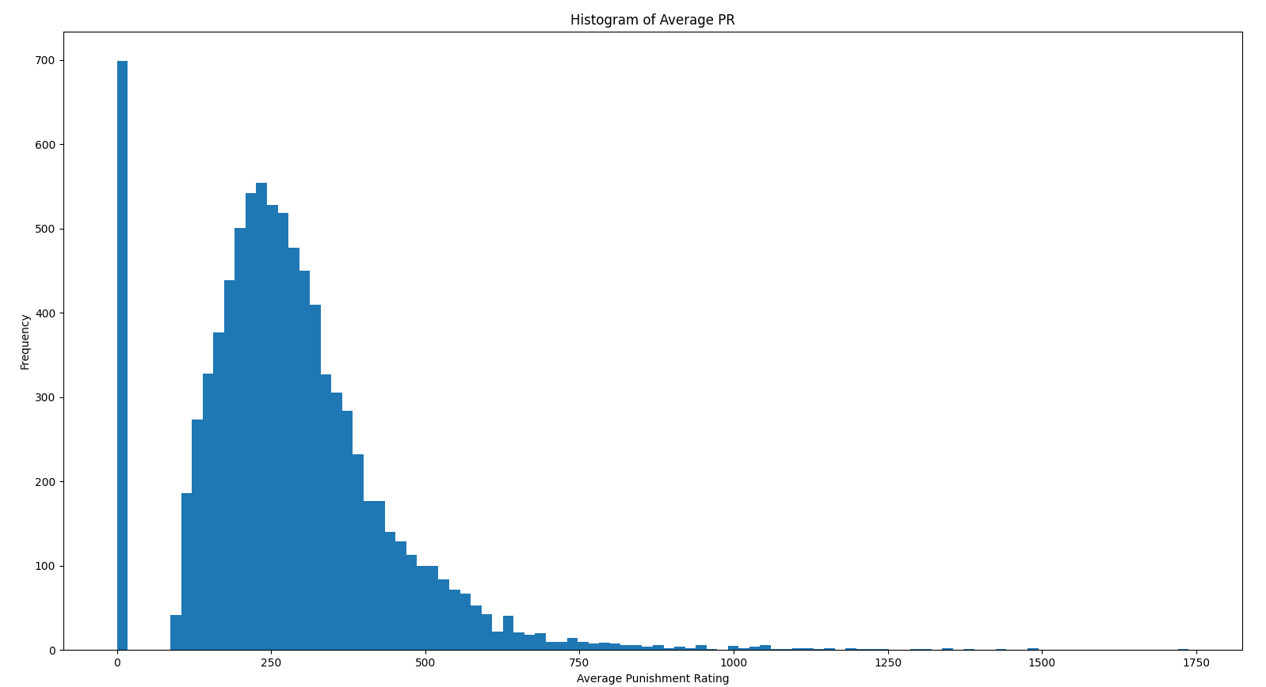
To visualize the distribution of Average PR, a histogram was created. As shown, there is a huge spike in games dominating the 0 average range, with the rest of the values following an inspiring right-skewed distribution.

2nd Variable – Games Played per Session
The second variable aims to group up games played in a single seating and label them with whole numbers like 1, 2, 3, 4… to signify the order and number of games played in a particular session. In order to achieve this, a Python script was crafted to log the dates of every PGN file, then grouping games that ended within 15 minutes of each other. It then assigns a number to each game representing its location on the session.
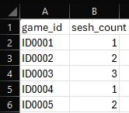
As shown, the code correctly groups games into their respective sessions in SessionCluster.csv.

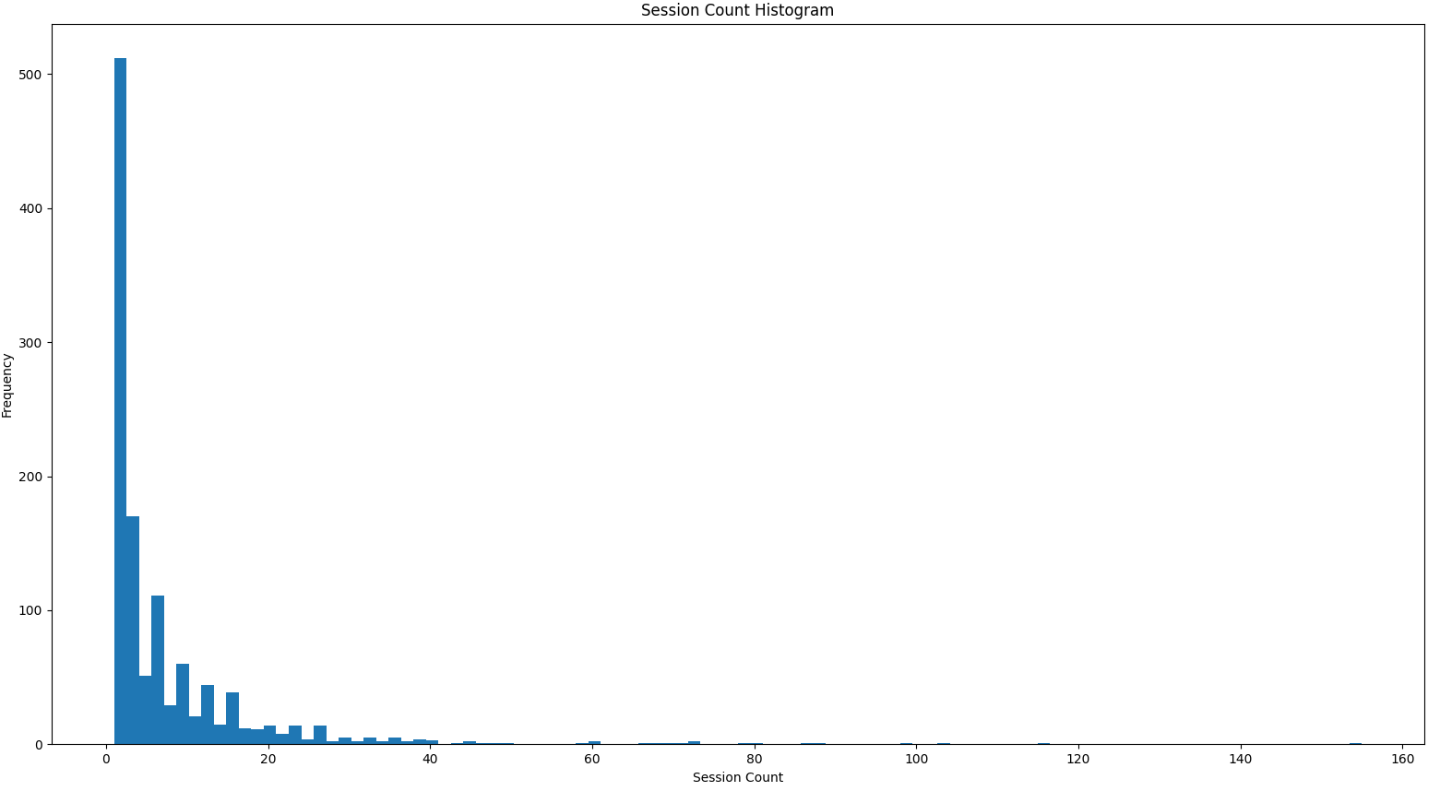
The generation of Session Count Histogram yielded 1,182 individual sessions, or around 38 sessions per month (December 2022 – June 2025). This averages to a little over a session a day for two and a half years straight, which to be frank is pretty ridiculous. The most dominating values are single game sessions by far, with the most extreme value being 155 games in a single seating.

3rd Variable – ELO Loss/Gain per Session
The third variable aims to find the difference in ELO between the first and every other game of its session. To do this, the SessionCluster.csv file that was created in the earlier chapter will be put to use. The general logic behind this algorithm is to store all the ELO values from the PGN files in a dictionary with their corresponding game_id as its key. After this, the algorithm will then parse through SessionCluster.csv to identify new sessions and calculate the rating difference of each session game to their respective starting ELO.
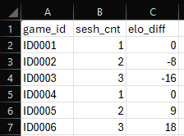
As shown, each session start (sesh_cnt = 1) has an elo_diff of 0 as its value is basically its rating minus itself, while every game after compares their ELO to it. The output will either be a negative or a positive value, signifying either a net gain or loss.
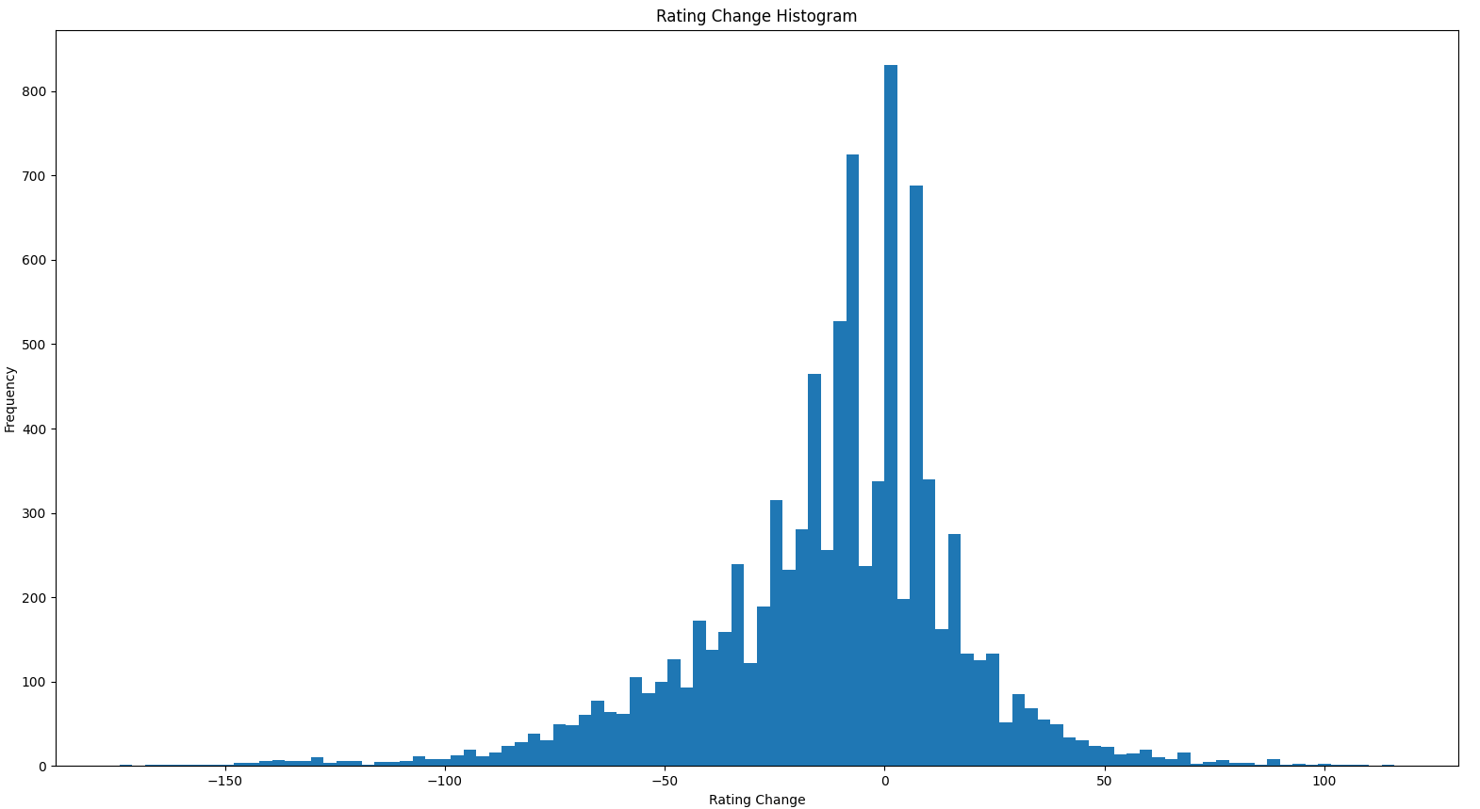
This produces a somewhat disappointing looking histogram that resembles a slight left-skewed distribution. This is due to the fact that the majority of sessions ends after losing or winning 3 to 4 games, resulting in an influx of values that are multiples of 8 (the average ELO gain/loss). The dominance of 0 values indicate either session starts or unrated games.

4th Variable – Streak Record
This variable is obtained by parsing the results column in AveragePR.csv and calculating how many wins/losses were achieved before it. Then, it stores this value as an integer with a positive number indicating wins in a row and a negative number indicating losses in a row. Draws will always be counted as 1. The values will then be stored in StreakRecord.csv.
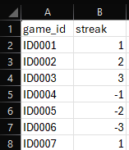
As shown, this produces a simple dataset with only two self-explanatory columns.

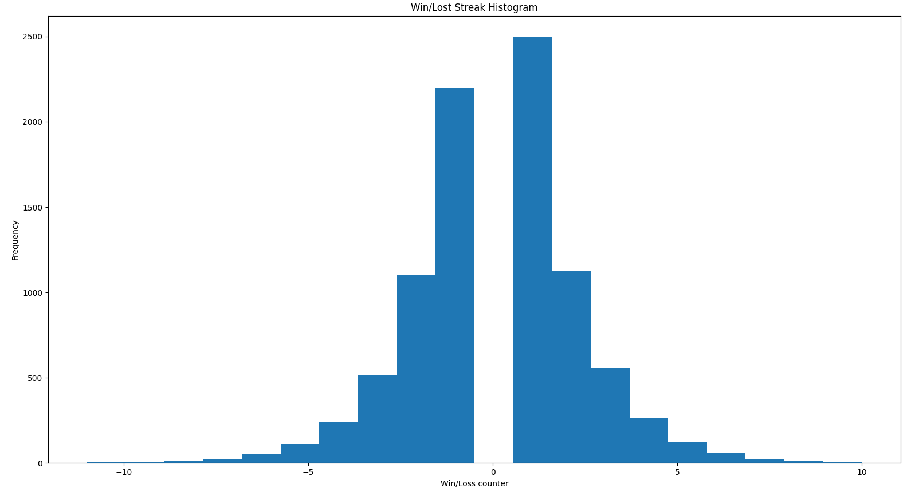
The histogram produced by this dataset shows a chart that resembles a normal distribution without the zero value. This is because streaks always starts with 1 or -1 and counts up or down from it.

4.0 Problems in the Dataset

4.1 Unrated Games
Thanks to the 3rd variable (ELO Loss/Gain per Session), a major flaw in data collection was discovered – unrated games, which aren’t affected by emotions, are present in the dataset. The discovery of this issue was due to a huge amount of games that do not affect rating points after a brief visual inspection.
Start ID | End ID | Total
ID2721 | ID2739 | 19
ID3112 | ID3122 | 11
ID5732 | ID5738 | 7
ID5908 | ID5928 | 21
ID6881 | ID7228 | 348

In total, 406 games will have to be removed from the dataset as they are all unrated games.

4.2 Duplicated Games
Thanks to the 4th variable (Streak Record), another major flaw was found in the current database. An entire page of chess games containing 50 games was downloaded twice by accident. This in turn means that an additional 50 games will have to be removed from the dataset to prevent overfitting. This issue came to light when four instances of double draws were found within 100 games of each other, which is an extremely unlikely amount.
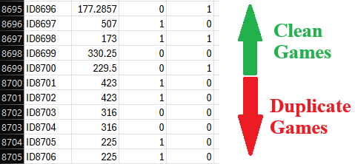

5.0 Compilation of the Final Dataset
After the issues mentioned were fixed, the final dataset called FinalDataset.csv was created. In it, all the variables that were calculated was compiled into a single file. Shown below is the first 20 lines of the final dataset. In total, there are 8542 games that will be used for training.
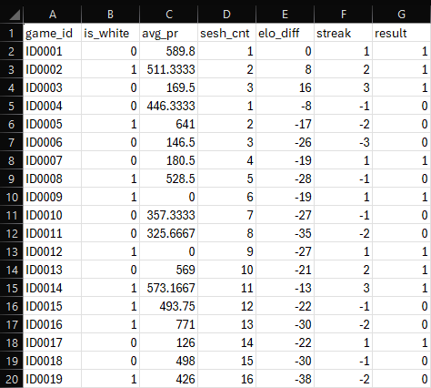
Variable | Description
game_id | Unique identifier for each game in the dataset
is_white | Returns 1 if the target player is white and 0 if black
avg_pr | Average Punishment Rating per game from Stockfish evaluations
sesh_cnt | Session count of the current session (Games 15 minutes from each other)
elo_diff | Rating difference compared to the start of the session
streak | Wins/Losses in a row (Positive = Wins, Negative = Losses)
result | Game result, the dependent variable

6.0 Dataset Preprocessing
On Jupyter, the dataset was first loaded in using the above command. As shown, there are 8542 rows and 7 columns in the dataset.
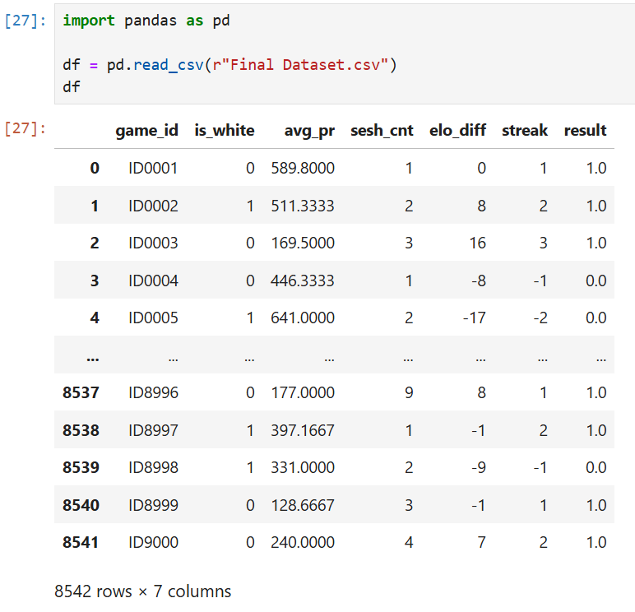

Next, the game_id column is dropped as it carries no value for model training purposes.
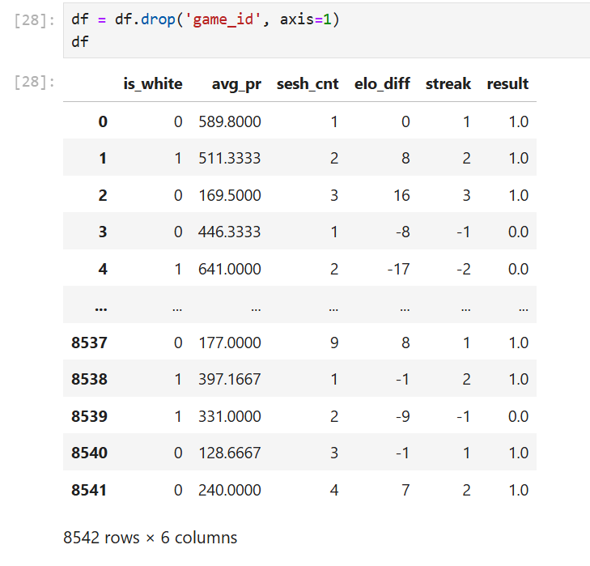

Additionally, the result column was changed so that its values are no longer quantitative but qualitative. This is because a Random Forest Classifier algorithm doesn’t need the target variable to be in a numerical value.
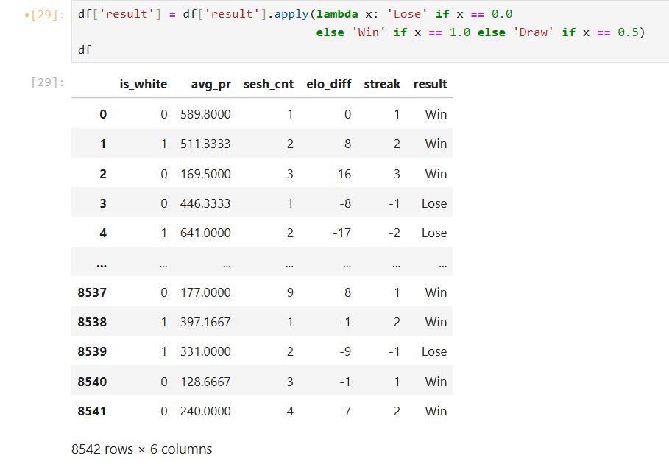

The image below shows that the result tab now only contains the values “Win”, “Lose”, and “Draw”.
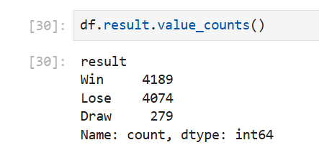

Finally, the columns’ values can now be visualized on histograms.
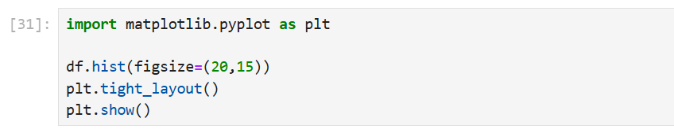
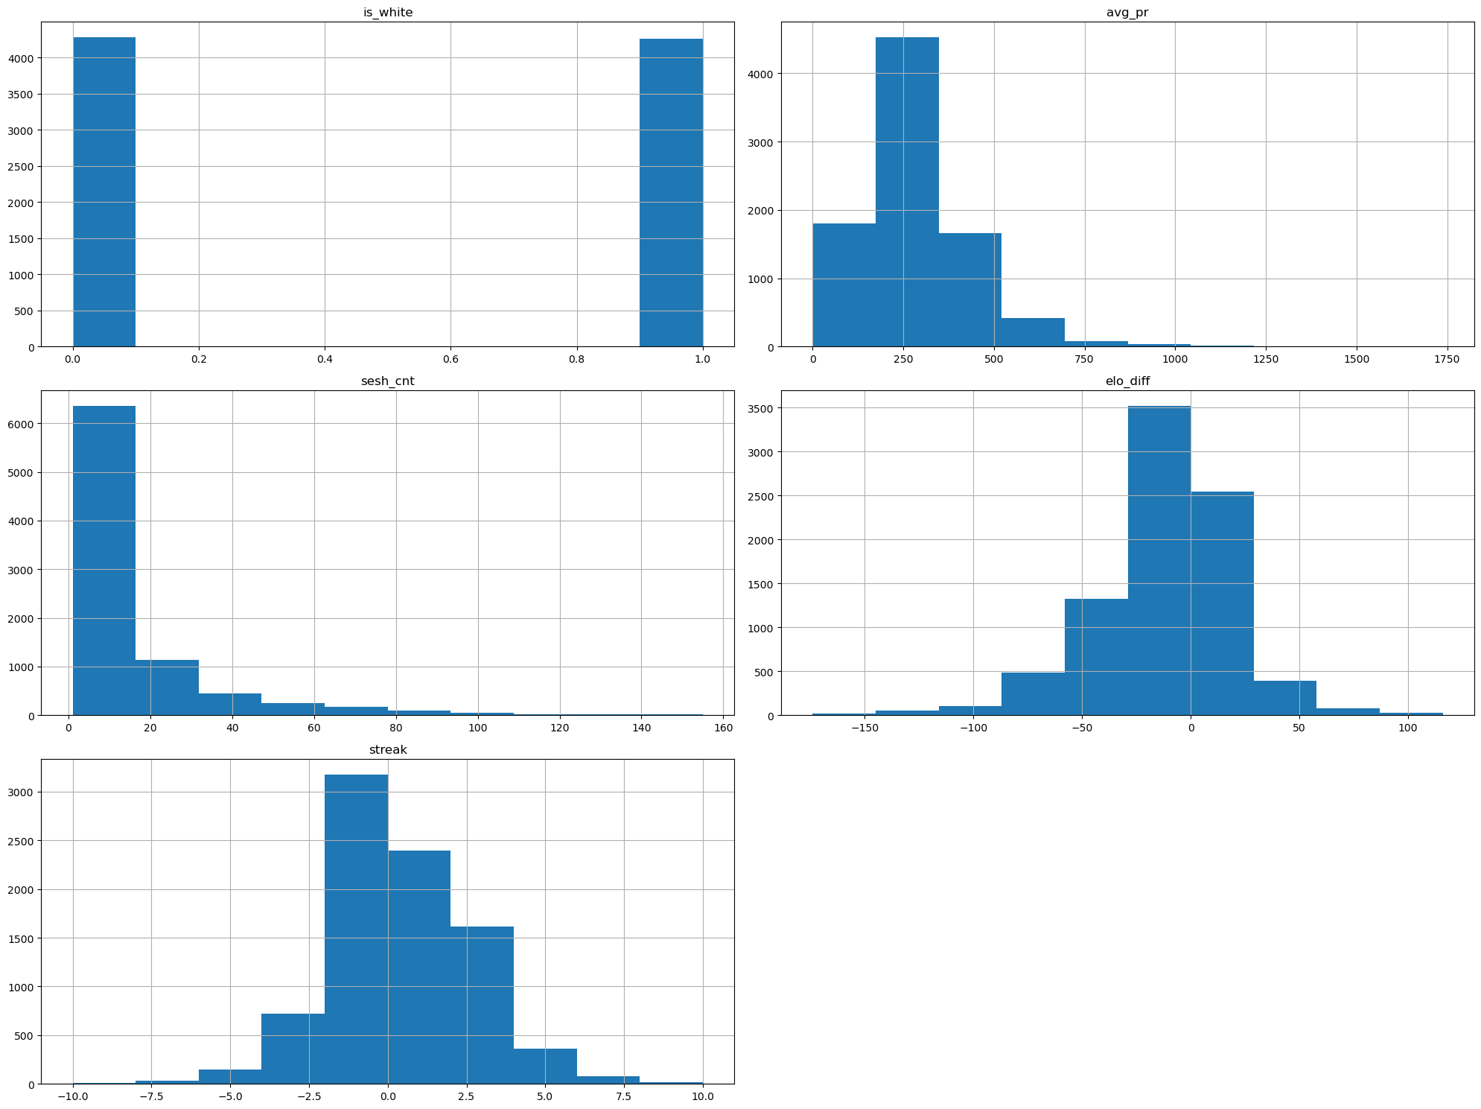

7.0 Model Training #1
After the preprocessing is completed, the model can then be trained using the following code:
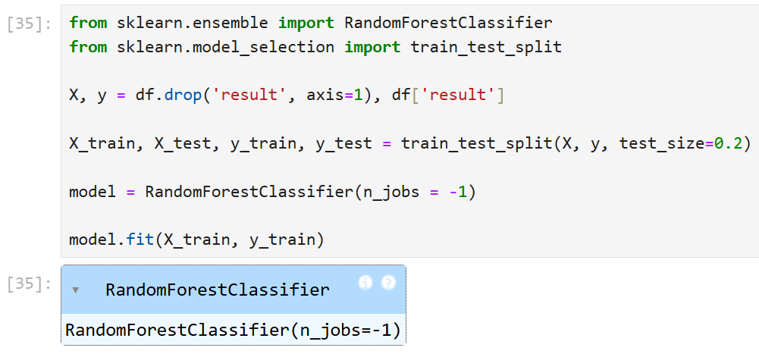
This uses the Random Forest Classifier module from Scikit Learn to train a model based on an 80/20 test split using a random selection. This produces a model which can then be tested for accuracy.

7.1 Model Accuracy Score
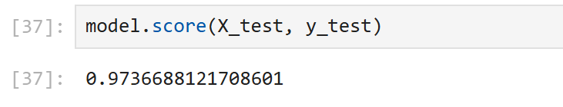
As shown, the model was produced with a 97% predictive accuracy, which is unbelievably good for a project this new. Moving on, this model will be integrated into a browser extension that extracts features from active players and predicts their game results. Before that however, the importance of each feature in affecting the match result will be explored.

7.2 Feature Importance
Further analysis show that the most significant feature is streak, dominating the model with an 83% importance. This is slightly disappointing as the model is essentially finding the pattern that winning or losing a bunch of times will eventually lead to a particular result.
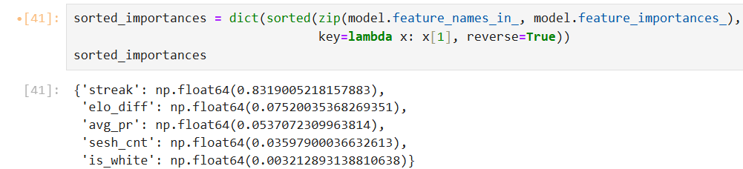
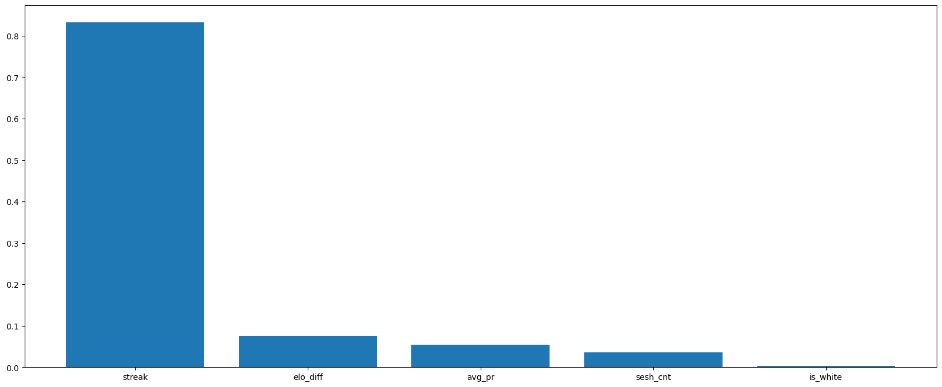
To explore further, the dataset will be tweaked to figure out the model accuracies when different features are dropped.

7.2.1 Dropping streak in the Dataset
By dropping the streak column, the model will average a 62% predictive accuracy.
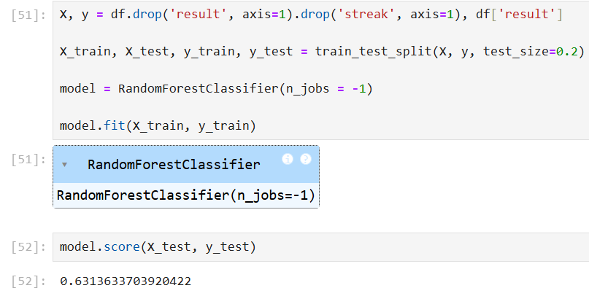

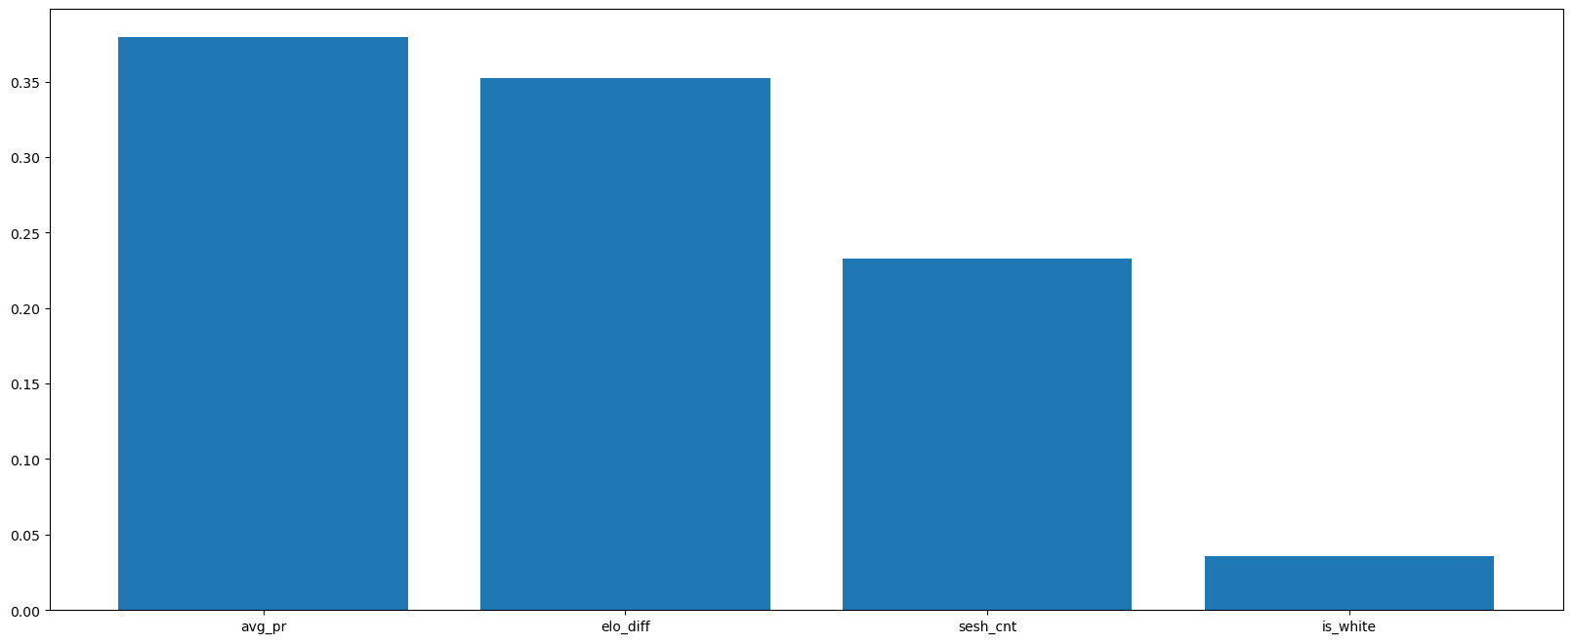
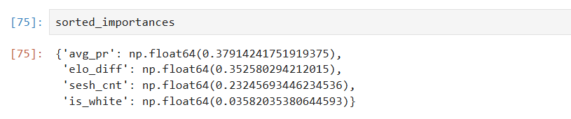

7.2.2 Dropping Everything but streak
By only keeping streak in the dataset, the model achieved a whopping 97% accuracy, further proving that streak is the only variable that’s significant in the dataset.
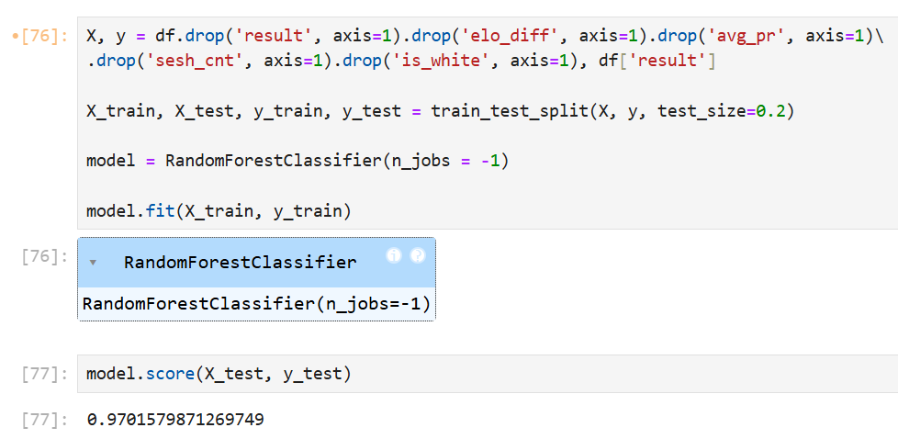

After investigating, it seems that the model accuracy being this high is reflected by the fact that the value of streak is 100% based on the game’s result, which shouldn’t be the case. In other words, the value of streak can only be achieved after result is determined (e.g. -1 for a loss), which won’t work as streak will function as a dependent variable.
To fix this, streak will be modified to only include the streaks of previous games, leaving the current game to be predicted by the model.

8.0 Model Training #2
A simple algorithm was made to fix the values of streak so that it gives only the information of games before it. This is done by adding 1 to negative values and subtracting 1 from positive values. Then, the model was retrained and achieved an accuracy of 77%. This is significantly lower than the first model, but still high enough to not be considered random chance.
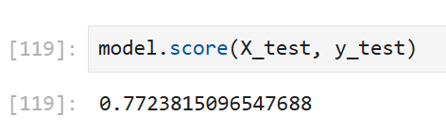
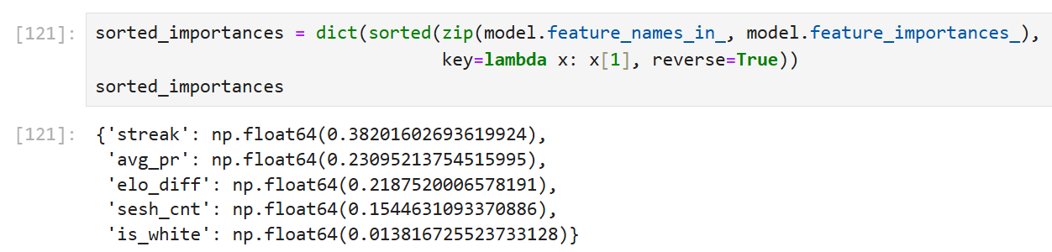
As shown, the most significant value is still streak, but this time with a more balanced importance distribution.

8.1 Feature Importance
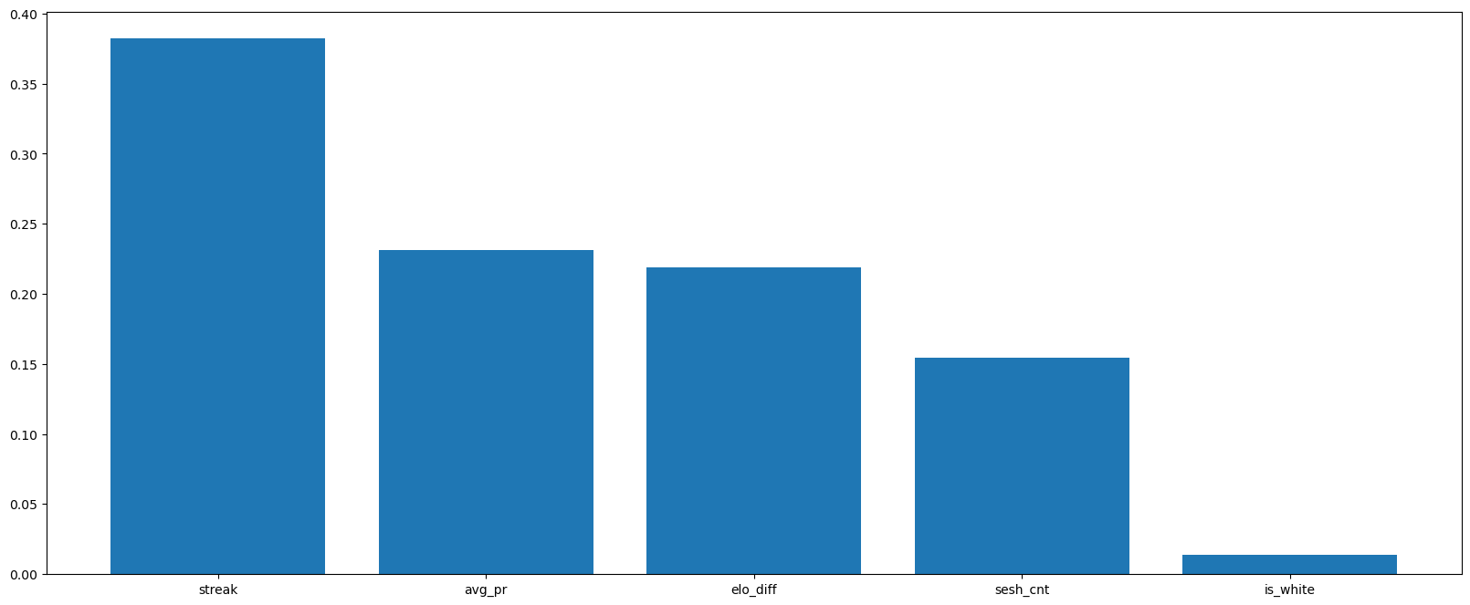
The bar chart above shows the importance of every variable in the dataset in the context of predicting result.

8.2 Confusion Matrix
